Beekeeping Guide

Course: CSC5022 Advanced Web Systems

Github Version Control link: <https://github.com/Kronic101/Bee-Keeping-Guide>

Members: David Zulu

Wila Mwila

Tandeo Nawa

Chongo Mwesa

**Beekeeping/ Apiculture** is the maintenance of bee colonies, commonly in man-made hives, by humans.

A beekeeper (apiarist) keeps bees in order to collect their honey and other products that the hive produces, such as beeswax, propolis, follower pollen, bee pollen, and royal jelly, and royal jelly, as well as to pollinate crops or to produce bees for sale to other beekeepers.

A beehive is an enclosed structure in which some honey bee species of the subgenus Apis live and raise their young.

A location where bees are kept is called an apiary or “bee yard”.

**Importance of Beekeeping in Zambia**

Beekeeping and honey hunting improve diets for an estimated250,000 farmers and are an important source of income for 20,000 rural households in Zambia. These activities are done during the time when labor demands for agriculture are low, thereby providing alternative employment for rural people.

The Beekeeping guide will be for a modern hive built for the soul purpose of maintaining bee colonies.

The Beekeeping guide will work on measurement of the parameter’s below collected on an interval and entered into a Django Python web interface and will return results showing the status of the man-made hive

Measurements will include:

1. Audio Recordings
2. Hive Temperature
3. Temperature Accuracy
4. Hive Humidity
5. Humidity Accuracy
6. External Temperature
7. External Humidity
8. Atmospheric Pressure
9. Wind Speed
10. Wind Direction
11. Weather Forecast

**MVC Pattern**

The system is to be built in Django Python. However, Django uses the Model-View-Template which is slightly different from the MVC (Model, View, Controller). The main difference is that Django itself takes care of the Controller part (Software Code that controls the interactions between the Model and View), leaving us with the template. The template is an HTML file mixed with Django Template Language (DTL). Below is a diagram illustrating the MVT pattern

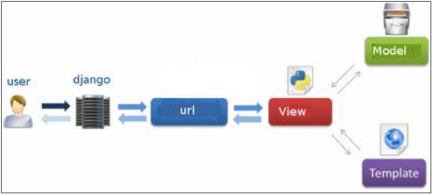

We provide the model, the view and the template then just maps it to a URL and Django does the magic to serve it to the user.

**SCHEMA & DATABASE**

We have two schema’s below showing the operation of the system from the Farmer to the guidance database and back with results for the farmer.

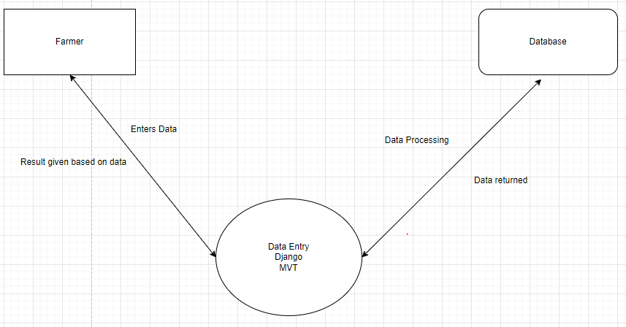

Below is a database diagram showing the tables to be created and the relationships between them.

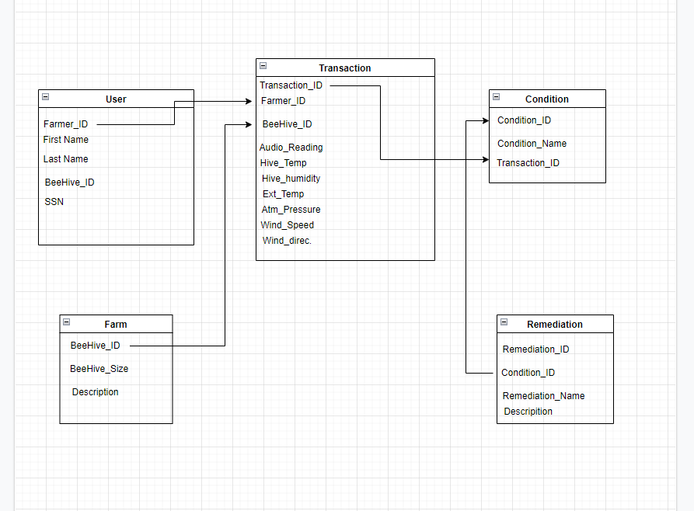

**DATABASE TABLES**

The beehive database has been created with the following tables (shown on the left side of the diagram):

* farmer: For farmer information storage.
* farm: For beehive details storage.
* transactionbee: For storage of the various parameter measurements to be taken for the effective monitoring of the beehive.
* condition: For storage of the beehive condition resulting from the measurements taken.
* remediation: A description of remedies to be used for the resulting conditions.

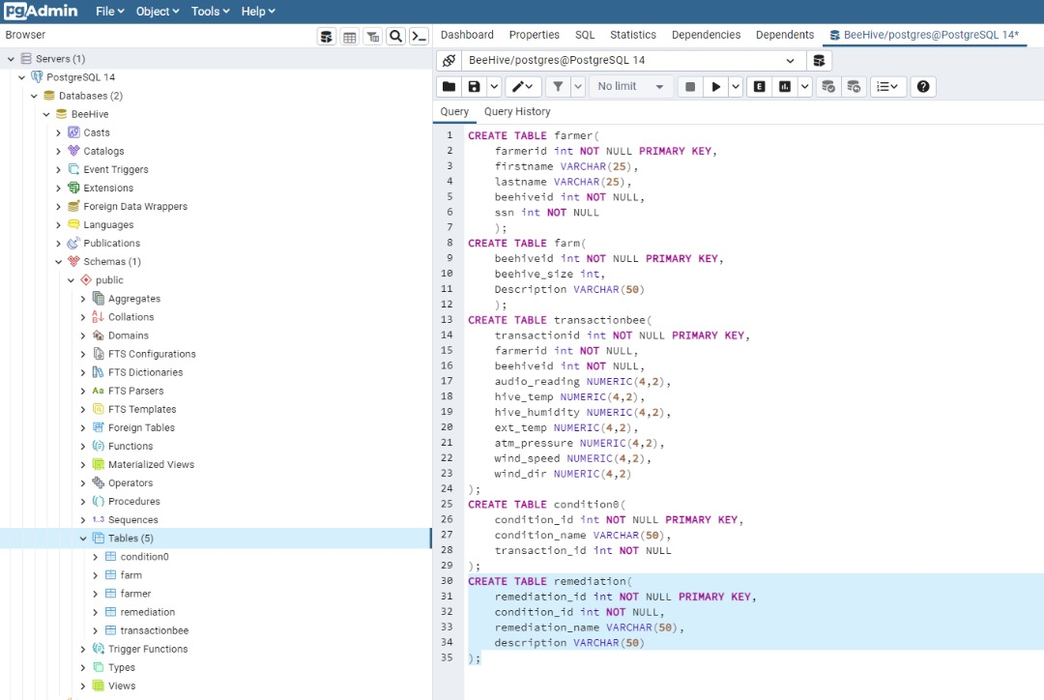

The diagram below shows the Entity Relation Diagram of the database tables created:

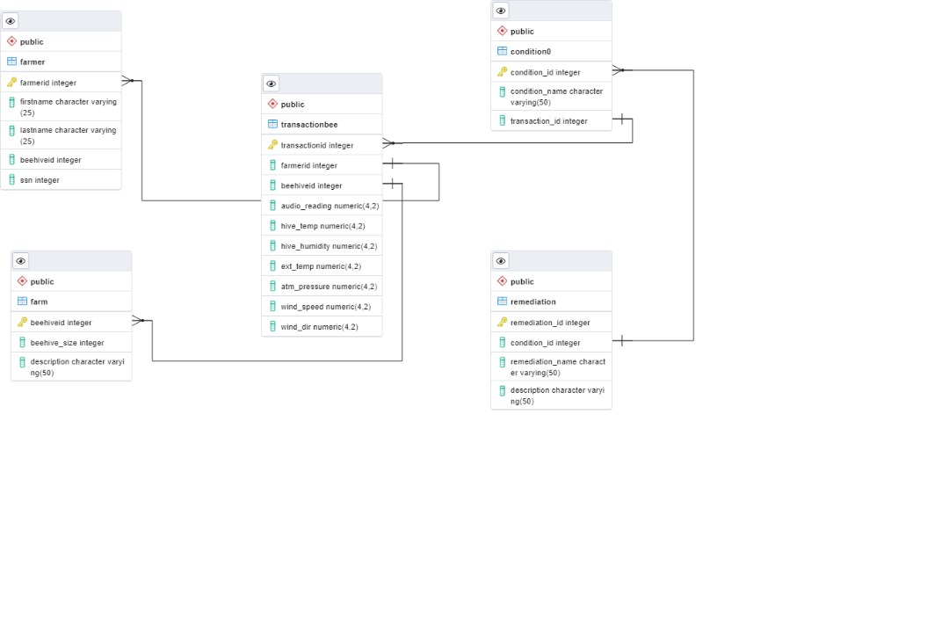

DB Admin Username: beehiveadmin

Password: 1234

